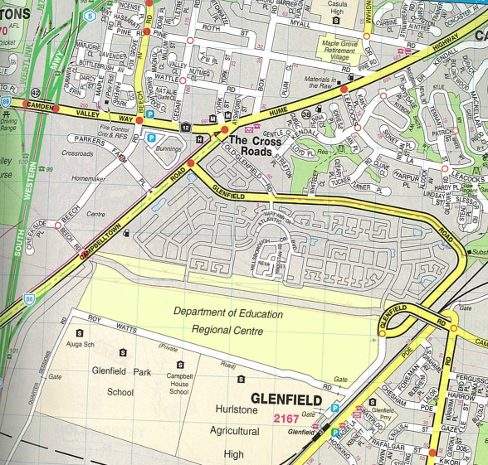
Travel Instructions
KEY
Green X - Denotes Glenfield Railway Station
Red X – Denotes Glenfield Suspension Centre
Blue X - Denotes Comfort Inn Hunts Conference Centre

Walking, follow the green line - From Glenfield Railway Station, take a few minutes to walk to the Glenfield Suspension Centre
Driving to Hunts, follow the blue line - From the Glenfield Suspension Centre, take the first left towards the roundabout
- At the roundabout take the 3rd exit onto Glenfield Rd and proceed to the end of the road
- Turn left at Campbelltown Rd and proceed to the traffic lights, travelling in the right lane
- Turn right onto Beech Rd
- At the roundabout, take the second exit
- At the next roundabout, continue on Beech Rd, taking the second exit
- Turn right at the traffic lights on Camden Valley Way
- Continue along Camden Valley Way, and take the second left into York St
- You have now reached your destination! (Comfort Inn Hunts)

Parking Facilities
- Travel through green gate at Roy Watts Rd and proceed to first driveway gate on the right, at Liverpool District Office (Round marker)
- Proceed on road and turn right on gravel road towards grassed area at the front of the Glenfield Suspension Centre (square marker)

